**DOCKER AND KUBERNETES COMMANDS**

NOTE: - We will be running below commands from the microservice folder where we have created DockerFile.

Step 1: - Check the minikube version installed in system:



Step 2: - Now, we need to provide a driver where we can run minikube cluster. In our case we will use Docker:

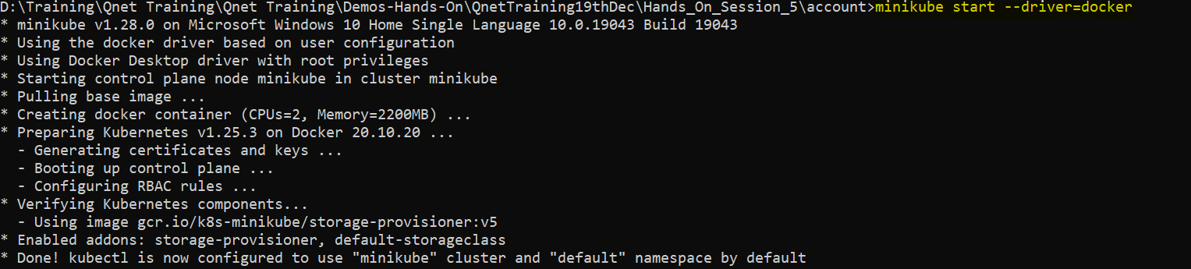

Step 3: - Now check the minikube status

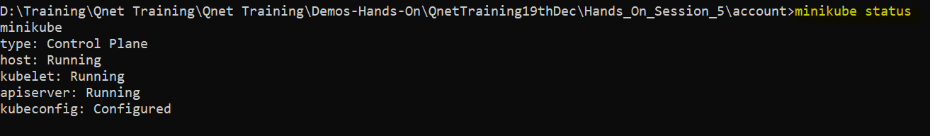

Step 4: - Now run below command to setup docker env in minikube cluster.

(Note: - There are two commands that needs to be run here.)

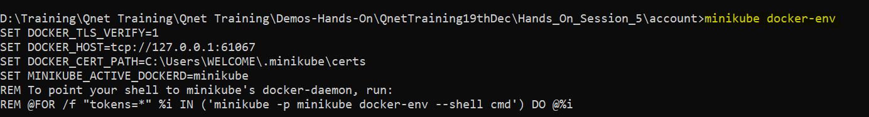

Now, copy the last line from above screen shot output and run as is. Check below screenshot for reference.



Note: - we have not copied ‘REM’ while running the command.

Step 5: - Now create the docker image of microservice that needs to be deployment in kubernetes pods.

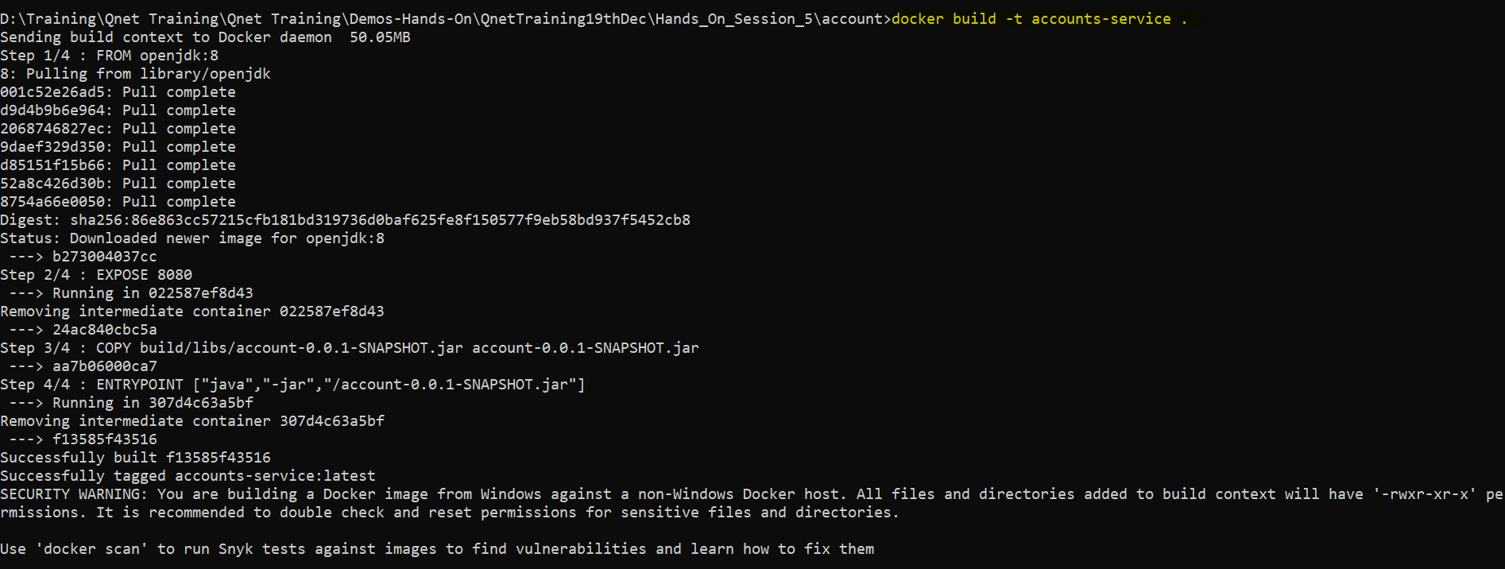

Step 6: - Once you have created the image successfully, try running below command to see the image which was created.

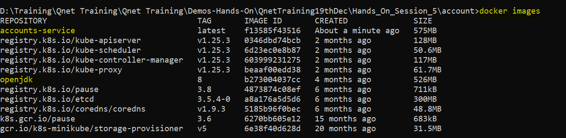

Step 7: - Now create the deployment object yaml file. Run below command to generate one.

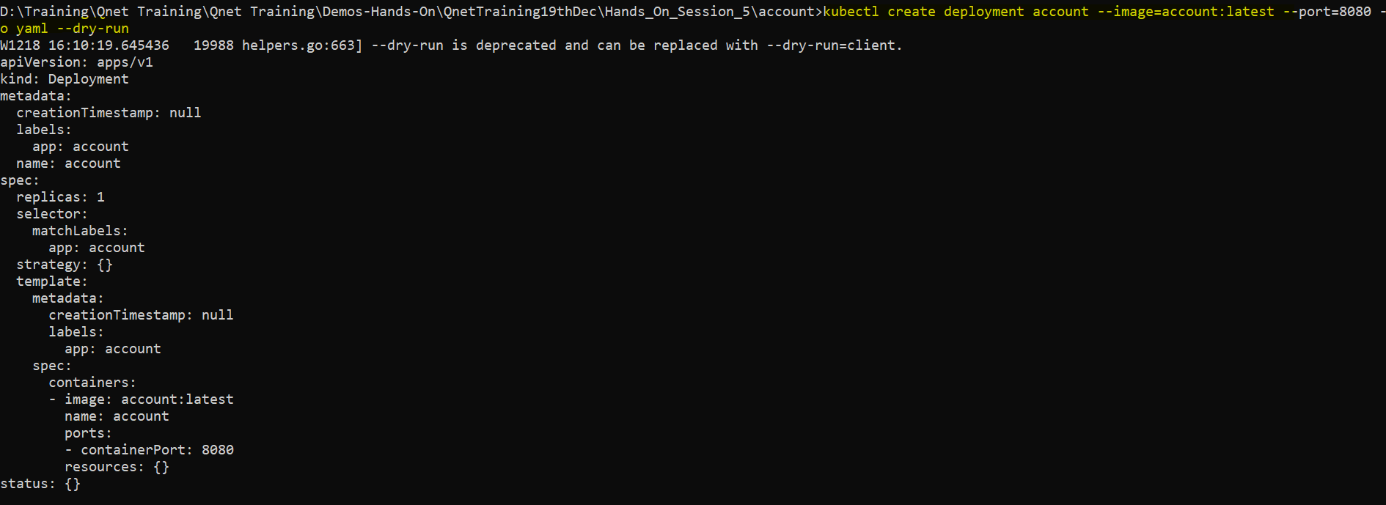

Note: - We need to add one attribute in the yaml file which is generated from the above command.

imagePullPolicy: Never

Now copy all the output generate in a separate file. Attached one for your reference.

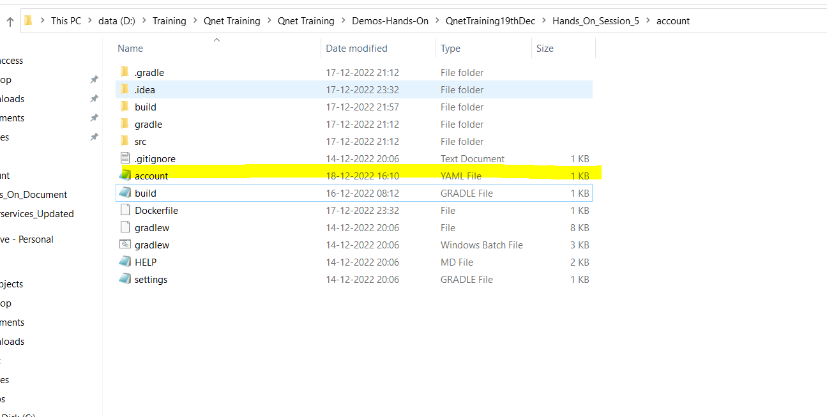



Step 8: - Now apply the yaml changes for creating the deployment object



Step 9: - Run below command to check the deployment object and the pods.





Step 10: - Check the pods logs to see if the docker image is successfully deployed in pods.

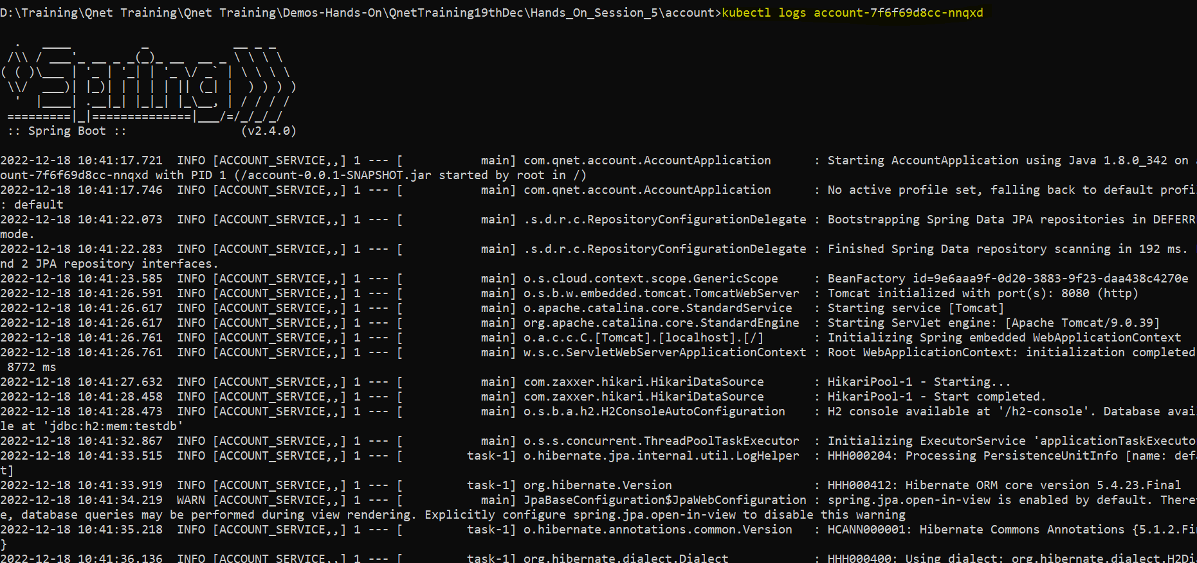

Step 11: - Expose the deployment object to be access by service component.



Step 12: - Fetch the service with below commands



Step 13: - Fetch the url to access the application

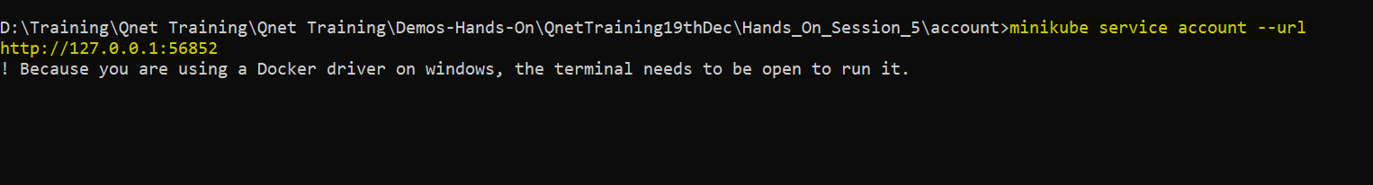

Step 14: - Try to access the microservice endpoint

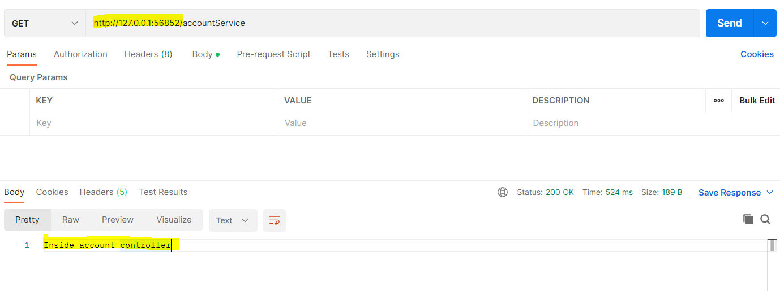

Step 15: - You can access the kubernetes dashboard with below command

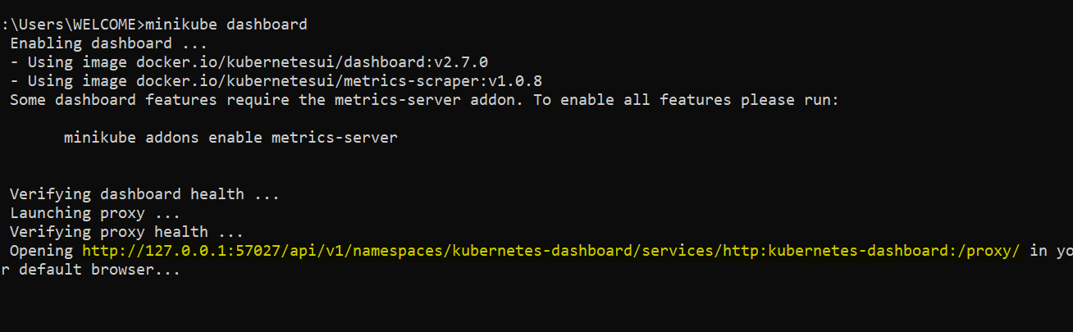

Dashboard page: -

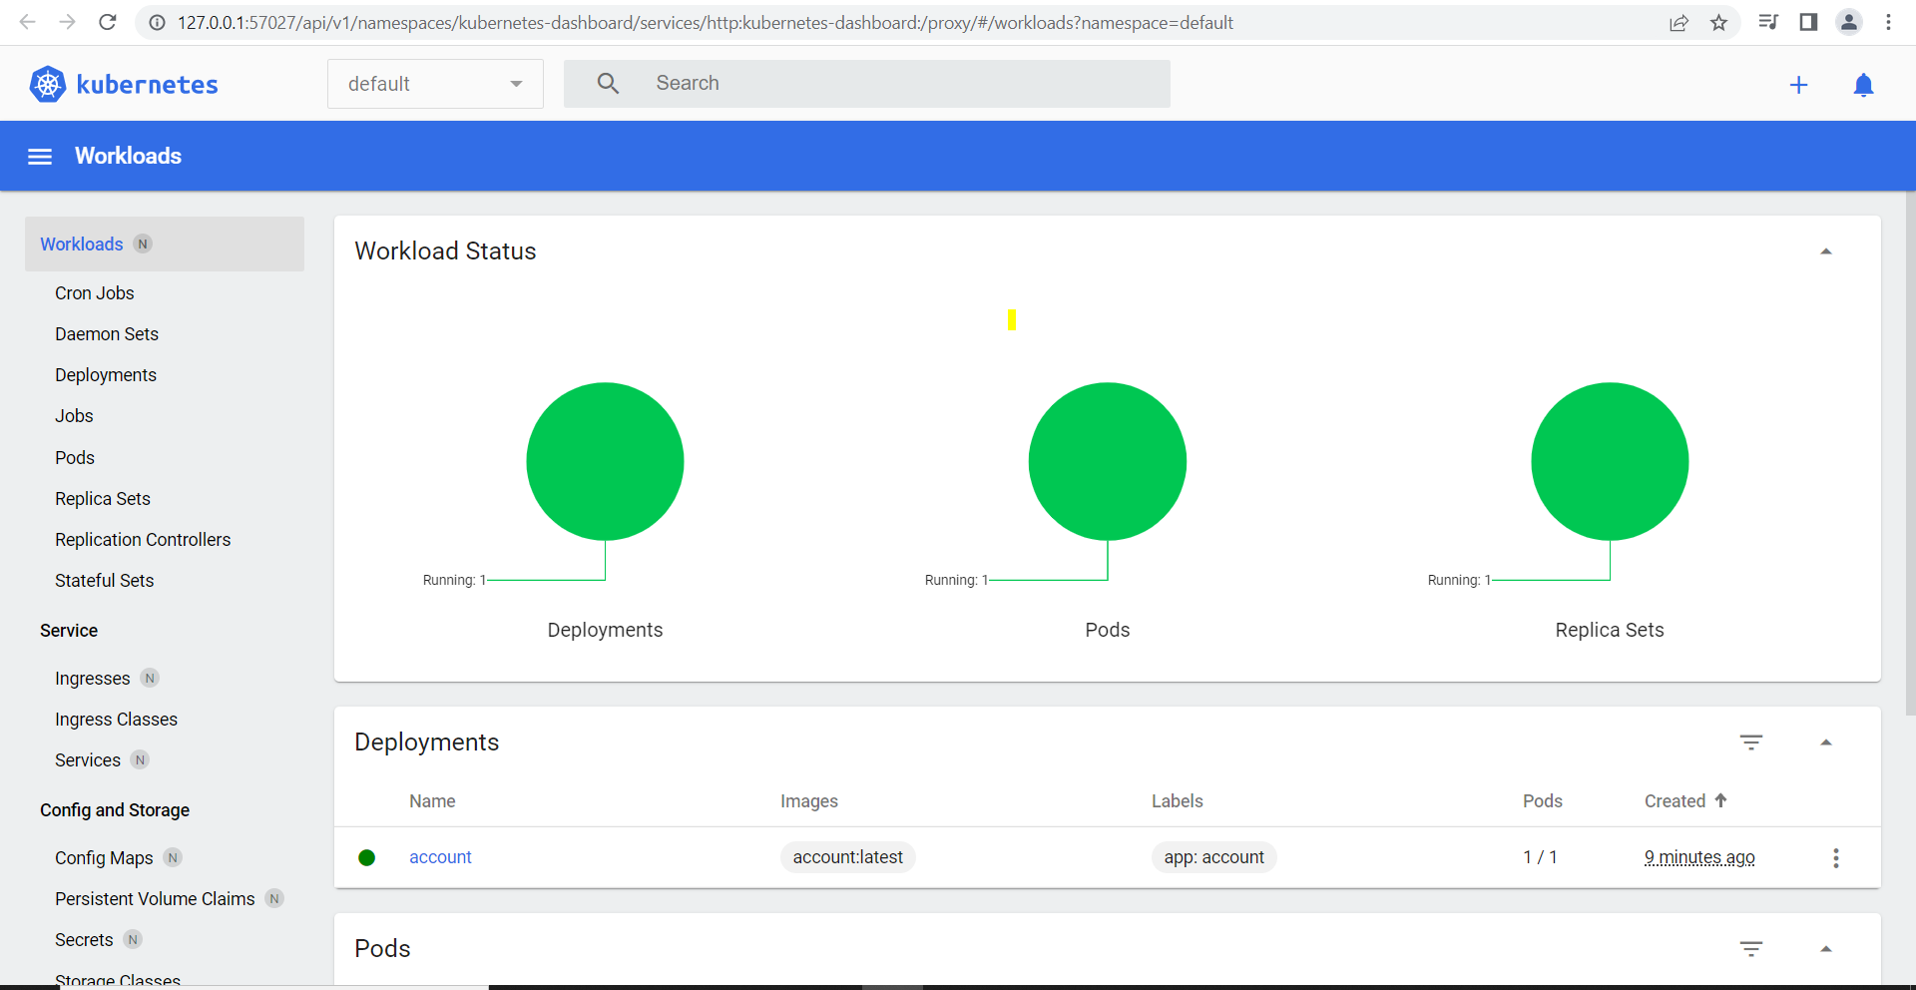

CLEANUP ACTIVITY

Step 1: - Delete the service



Step 2: - Delete the pod



Step 3: - Delete the deployment

Note:- You can get the deployment object name using command

kubectl get deployment



Step 4: - Stop the minikube to delete it.



Step 5: - Delete the minikube

